**Project Title**

Students Control Mobile Application

**Developed By:**

1. Keo Yinyong B20223600

2. Sous Naseu B20221460

3. Taing Khimsonita B20222067

4. Kun Kimhorng B20221472

5. Roem Hea B20221638

**Table of Content**

**Page**

1. Project Description 3

2. List of Important Requirements or Features 3

3. Project Architecture 3

4. Project Methodology 4

5. Tools and Technologies 4

6. Project UI Design 4

7. Quality Control and Testing 6

8. Communication 6

9. Project Development Difficulties 6

10. Lesson Learned 6

11. Conclusion 6

Conclusion

# Project Description

This project is called Student Control Mobile Application. It is an android mobile application that allow Students to survey about Teacher to School. Its objective is to make users become easier to survey. This project is done using Java Programming Language.

# List of Important Requirements or Features

* Create user account
* Login with Name and Password
* User can browse history survey
* User can add new survey
* User can view update or delete survey
* User can control the account

# Project Architecture

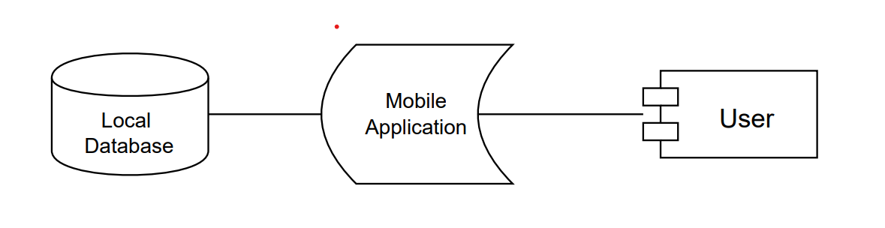

# Project Methodology

We have 6 steps in developing this project. First and second step is having idea of what application is going to be and who we build for. In the third step, we start define the application constraints. In the fourth and fifth step, we start to draw sketches of the application and create the prototypes of how the application going to look like. In the last step we have started coding and testing.

# Tools and Technologies

* Java Programming Language
* Android Studio IDE
* Figma UI Design
* Drawio Drawdiagram

# Project UI Design

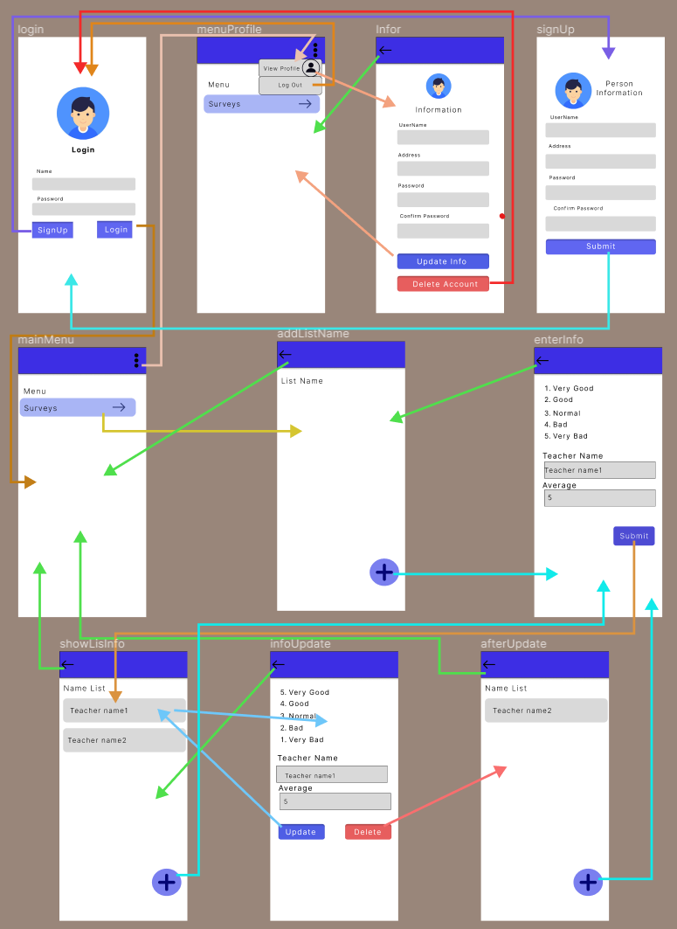

# Quality Control and Testing

This project can only implement functional testing to test if the requirements and features work perfectly. Due to time constraint, we cannot implement performance testing and usability testing for this project.

# Communication

Our team has ensured good communication throughout the entire project duration. We have arranged to meet and discuss the project 2-3 times during the development of this project. We also meet on a daily basis during our class time to have some additional discussion and questions.

# Project Development Difficulties

Throughout the entire duration of this project development, there are some difficulties that we have encounter. First, as the project is working Figma UI design, there are some difficulties in drawing diagram processing because it is our first time as using Figma as first project. There is also difficulty with integrating our code together as we divide separate feature to do individually.

# Lesson Learned

From the development of this project, we learned a lot of new things and experiences such as knowing how to use Figma UI design, having good communication with team members and make us understand about building project and how it’s processing.

# Conclusion

To sum up, Student Control Mobile Application is an application that allow user to brows and adds new surveying. This application is done through the use of Java Programming Language with Local Database.